Data Structures

* A data structure is a particular way of organizing data in a computer so that it can be used effectively. For example, we can store a list of items having the same data-type using the array data structure
* Which sorting algo will use to sort {1,2,3,4,5} ?

Ans. Insertion sort is best algo for sorted or nearly sorted array

* What is the difference between stack and queue?
* What is heap?
* What is a binary tree?

# **Tips to learn DS :**

* Implement from scratch bef solving problems : Array, String operations , Stacks, queues, linked list, hashmaps, trees
* Algos on these , post order traversal, dfs, bfs. How to apply algo iteratively & recursively
* Abdul bari

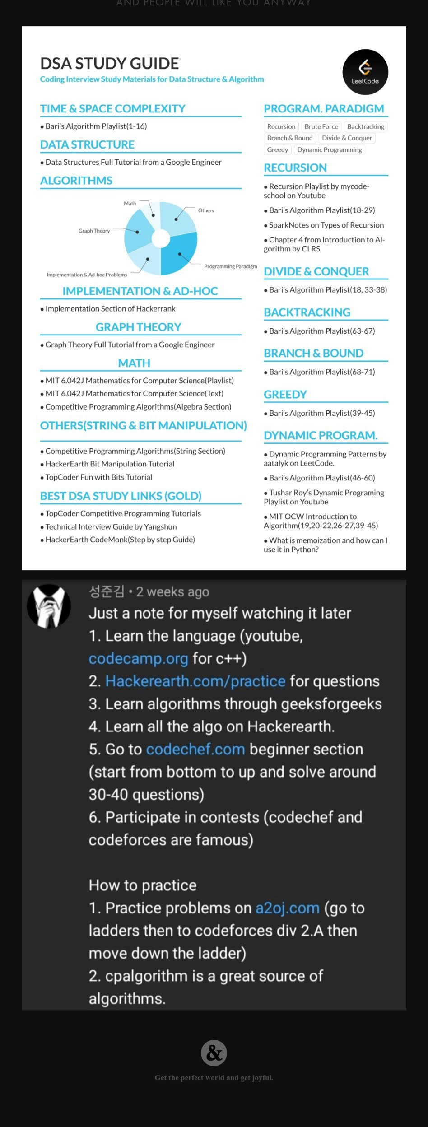



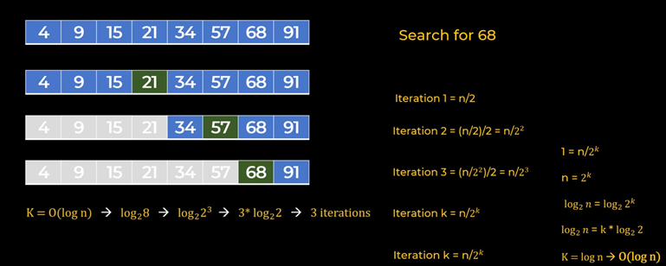

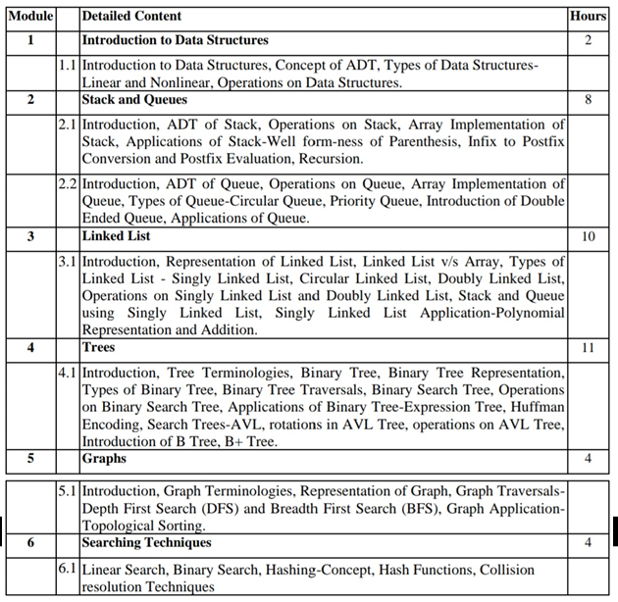

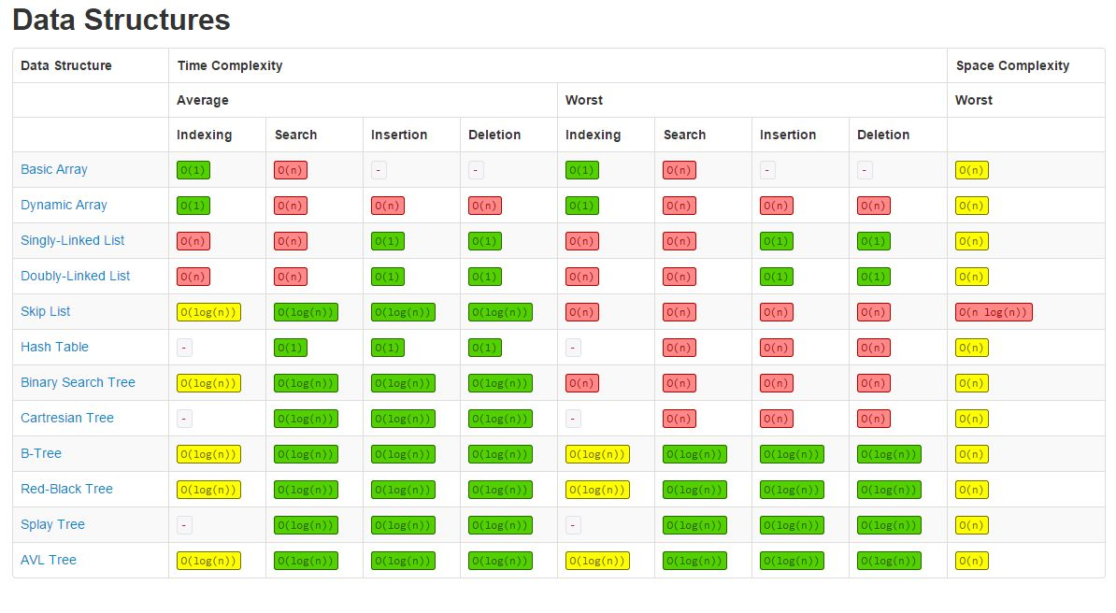

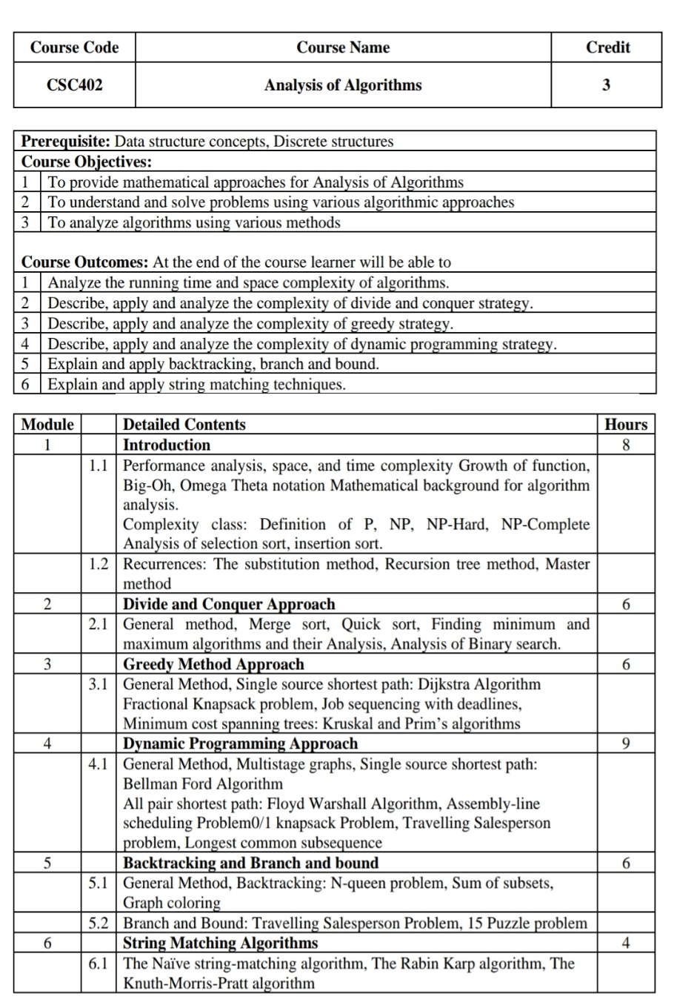

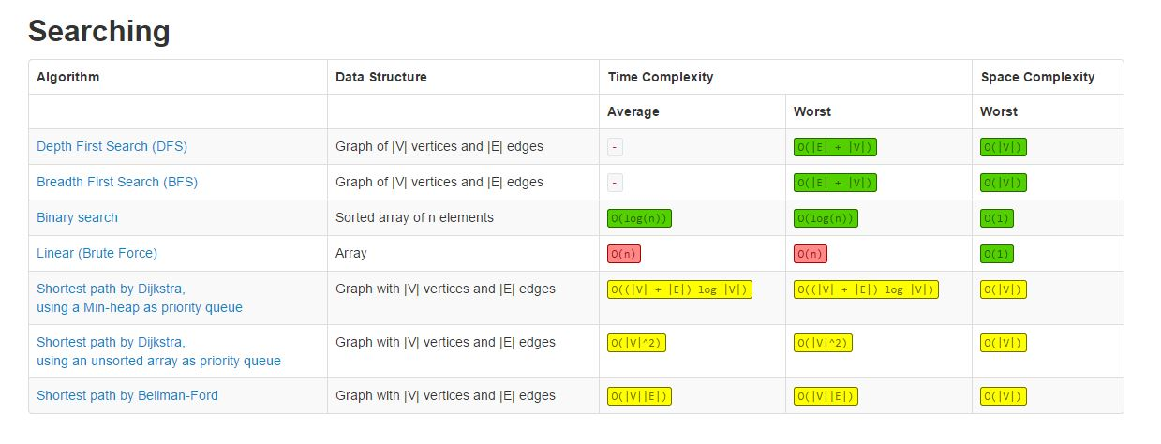

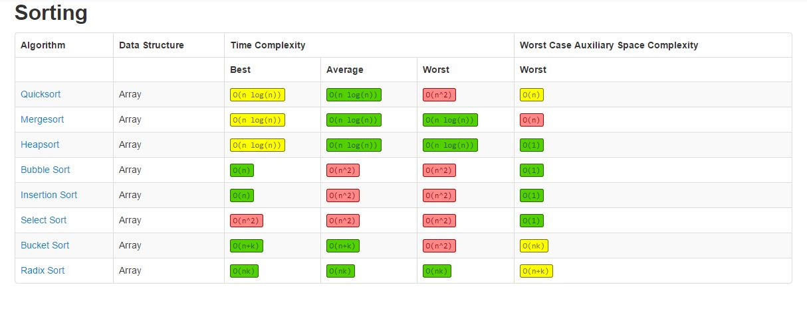

|  |  |  |  |  |
| --- | --- | --- | --- | --- |
| NADOS DSA TOPICS LEVEL 1 | | | | |
| Basics of Programming > 100 problems | Recursion and Backtracking > 30p | Dynamic Programming > 54p | Advanced Data Structure > 40p | Basic Data Structures > 107p |
| 5 sections  Getting Started : 14  Patterns : 22  2D Arrays : 10  String, String Builder and ArrayList : 6  Function and Arrays : 44  --> Duplicate : 31 | 5 sections  Introduction to Recursion : 9  Recursion with Arraylists : 5  Recursion in Arrays : 6  Recursion on the way up : 6  Recursion backtracking : 4 | 2 sections  Dynamic Programming and Greedy : 37  Time and Space Complexity : 17 | 2 sections  Hashmap & Heap : 20  Graphs : 20 | 5 sections  Stacks & Queues : 27 -----> Duplicate  Linked Lists : 26  Generic tree : 27  Binary Tree : 18  Binary search tree : 9 |